Congratulations to NERC’s scholarship recipients for 2021!

Find out more about these talented young runners.

Lydia Randolph of Jefferson

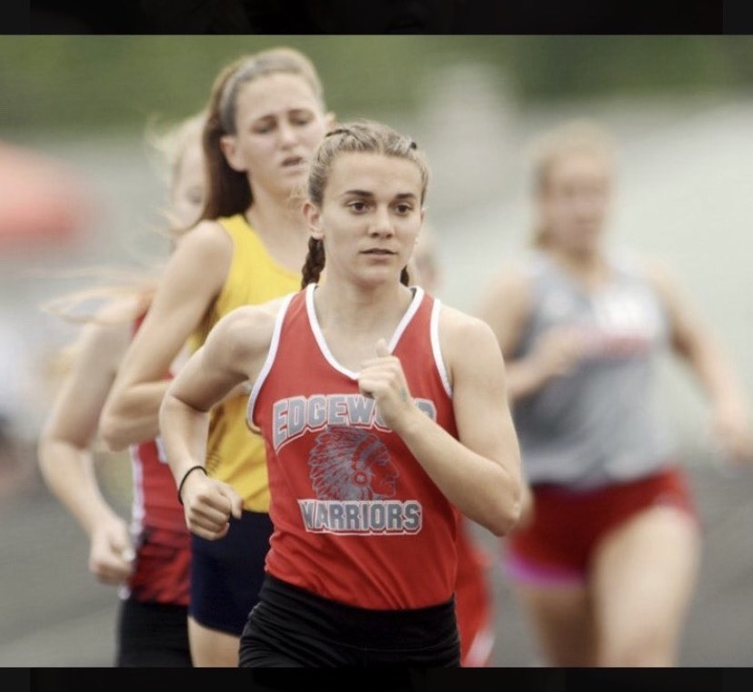

Winner of the Angela Pohl Inspiration Award ($1,000)
Edgewood High
Coach: Steve Hill
GPA 4.0/4.0 or 4.4/5.0
Will attend Trine University where she will study chemical engineering

Academic achievements
I have received honor roll (all A's) for all 4 years of my high school career. I have been awarded all academic Ohio for making it to states in cross country and receiving a certain GPA requirement. I have taken all AP classes my school has to offer while taking 2 extra AP classes that are online. I have also been deemed valedictorian for my class this year.

Cross country achievements
I ran at USATF National Youth cross Country Championships placing 17th and winning All American Honors and team placing 3rd. I won All-County Champion my senior year in the all-county cross country race. I have received first team all-county all 4 years of running cross country in high school. I received first team Chagrin Valley Conference my junior and senior year and All-American Conference my freshman and sophomore year before we switched conferences. I qualified for regionals all 4 years of my high school career and have qualified for the state meet for 2 years in a row.

Track achievements
I qualified to run at USATF music city Tennessee championships to run the 3200. I ran indoor track and qualified for the "indoor state meet" placing 7th in the 3200. I have qualified to regionals all my years in high school. I was a district champion in my events and the 4x800 for my team. I won Chagrin Valley Conference first team by winning my event in the 1600. I won first team all-county all my years in high school, but my senior year I won all my events in the 800,1600,3200. I won first team All American Conference my freshman and sophomore year before we switched conferences my senior year (no junior track).

Excerpt from essay
“I entered the world at 28 weeks (3 months early) only weighing 2 pounds and 11 ounces with a label distinguishing me as premature and with developmentally delayed mental and physical features. I remember sitting in meetings with school officials only to hear I was not able to perform at the level of a “normal” child and could not be in the same classes as my friends. In going to my primary doctor with this new established label put on me he examined me and knew this was not the case and to join running and extra-curricular activities.

I took on the battle of finding the person I am today by working hard and never giving up in being active in many clubs, being athletic, and focusing on my academic endeavors. Running eventually became my passion. In competing in many different distances and races it has allowed me to find my true passion that running is not only a sport, but a lifestyle.”

Alex Mohr, Paul Brunecz and Keaton Hahn

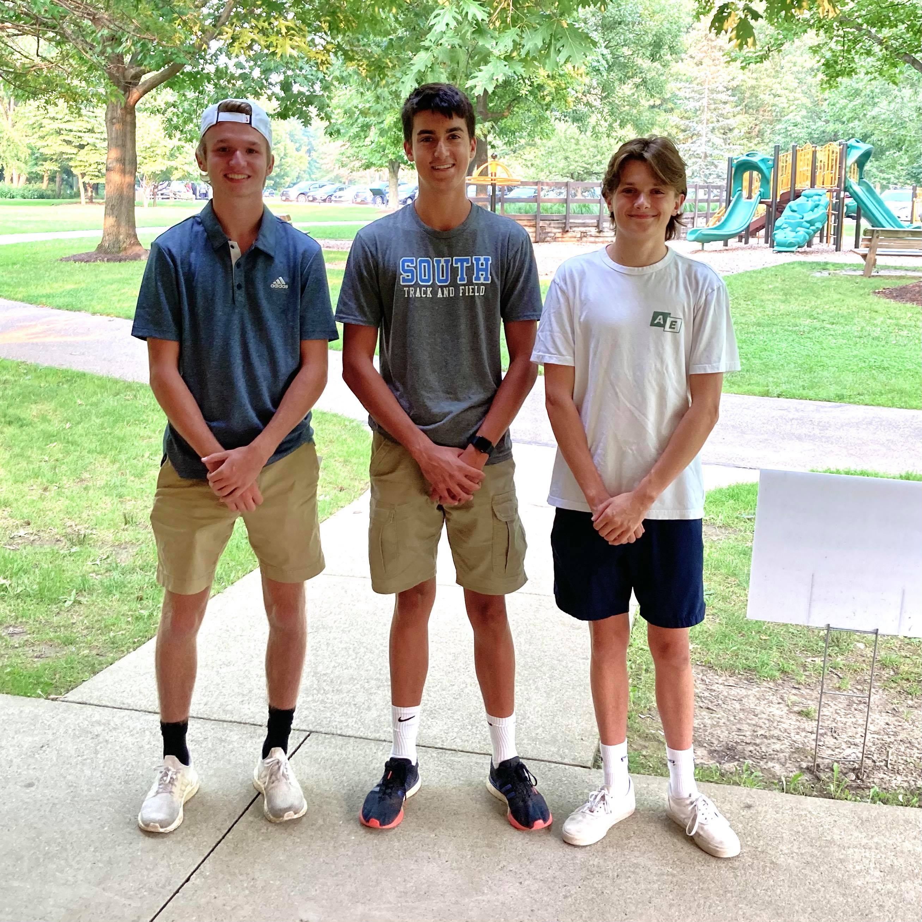

Keaton Hahn of Mentor ($1,000)
Mentor High School
Coach: Bill Dennison
GPA 4.429
Will attend Purdue University and plans to study Biological Engineering

Academic Achievements
National AP Scholar - AP Capstone Diploma - AP Scholar with Distinction - Suma Cum Laude - OHSAA Scholar Athlete Award

Cross Country Achievements
We went to state as a team (Senior Year) - News Herald Runner of the Week (Senior Year) - Outstanding Runner (Senior Year) - Captain (Senior Year) - All Conference (Senior Year) - Academic All Ohio (Senior Year) - Outstanding Junior (Junior Year) - Varsity Letter (Sophomore, Junior, and Senior Years) I ran varsity my junior and senior years. My Junior year PR was 16:59 and I was around 6th on the team. My senior year PR was 16:30 and we were all very close in time (there was a 2 second spread at conference).

Track Achievements
I ran varsity my senior year - Varsity Letter (Sophomore, Junior, and Senior years)

Excerpt from Essay
Looking back, running has made my life fuller. I can truly appreciate the value of hard work because that is what allowed me to make the friends that I have today. With those friends, I feel that I have become a more open and grateful person, who values that time that they have. Running allowed me to connect with kind people in a way that I would not have thought possible in middle school and some parts of high school and I am genuinely grateful for all the people it has connected me with.

Paul Brunecz of Willoughby ($500)
Willoughby South
Coach: Matt Luck
4.37 GPA
Will attend The Ohio State University and plans to major in Business Administration

Academic Achievements
Principal's list all 8 semesters of high school, top 15 in class, member of National Honor Society, graduate at Lakeland Community College while in High School, Graduate with Honors in High School.

Cross Country Achievements
4-year varsity letter man, 2 time team MVP, 4 time highest team GPA, team captain senior year, 2 time all conference honorable mention (junior and senior year)

Track Achievements
3-year varsity letter man, team captain senior year, winner of multiple 3200m dual races senior and sophomore year, one of the top point earners on my team senior year.

Excerpt from Essay
“Running has added a great amount of value to my life while in high school. Running has taught me to work hard in what you are doing. Whether it is running, working, or school, you have to do your best in order to succeed. Everything is earned and it is up to you regarding how much you want something in life.”

Alex Mohr of Painesville ($500)
Lake Catholic High School
Coach: Matt Borcas
4.35 GPA
Will attend The Ohio State University and plans to major in mechanical engineering

Academic Achievements
First Honors (2017-2021), 5th in my class, Elmira College Award

Cross Country Achievements
2020 District Runner Up, 16:42 PR, Individual Regional Qualifier (2018-2020)

Track Achievements
Indoor State Qualifier (4x800, 1600, 3200, 4x400)

Excerpt from Essay
“I have been a runner ever since I can remember. I have run road races with my family and have done track and cross country since 4th grade. Running has always been a part of my life and it has added so much to my life. One of the biggest ways that running has added value to my life is the people that I meet in the community of running. Whether it be just at my school or the community of northeast Ohio distance runners, I have met some great people who have become my greatest friends that push me to run at my best.”

