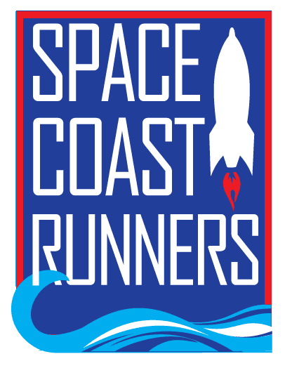
SPACE COAST RUNNERS
MINUTES OF October 2021 BOARD MEETING
Full Board Meeting - 7:00 PM EDT – In Person Meeting

Board Members / Officers Present: Debbie Wells (President), Terry Ryan (Secretary), Steve Hebert, Rachel Weeks, Kelly Kervin, Brittany Struefort, Donna Arnister, Marisa Flint, Stephen Bernstein, Kayla Cain
Absent: Caeley Looney (Vice President), Paul Boucher (Treasurer), Bambi Sweeney, Kim DelTorchio,
Meeting called to order at 7:07 pm
- Review of September Meeting Minutes – Terry: MTA by Steve, second Stephen, approved.

- Treasurer’s Report – Debbie for Paul: Debbie will ask Paul to clarify in the budget summary so that all items add up. MTA by Stephen, second Steve, approved.

- Sponsors Update – Debbie for Caeley:
    - We met Stephanie Lattner, owner broker of Lattner Group Keller Williams, whose office space we are using for our meetings. Space is large, comfortable and good location.
    - Brittany visited Dr Wade at Brevard Orthopedic Specialists (B.O.S.) they were not happy that another orthopedic doctor was at a recent running camp session. Brittany explained that the camp is totally separate from B.O.S.’s sponsorship of the race team and invited her to the winter social.
    - Debbie is to call Caeley to discuss getting Information on future opportunities to attend to our sponsors.

- Upcoming Events – Discussed pub run at Playlinda Brewery Oct. 19th, Neighborhood Fun Runs on 23rd and 28th at Ryckman Park, Malabar trail run prior to the Malabar Market on 23rd, Fall Nutrition workshop on 24th, November board meeting on the 15th, SCM Q and A event on November 7th, and the SCM week activities beginning the 24th.

- SCR Racing Team Updates – Rachel:
    - Placed 2nd at Running Wild
    - Next race is the Space Coast Half
    - Plans to track attendance as many members are missing races.

- Committee Reports
    - Social –
- Still in need of members, Terry has emailed race team with no response
- Hydration Sunday was well attended. Still having issues with H2O getting dumped out on North route
- Pub Runs – Pizza Gallery Nov 1st, Dirty Oar Dec 30^{th .}
- Winter Social Jan 16th at Oars and Paddles. Terry with help from Rachel and Kaley will hide the golden egg. Donna will make hard boiled eggs. Deb will get food and Paul drinks.

    - Racing Committee – Kelly
- Running Wild – one area was not well marked but overall a god race.
- There will be a survey in next month’s newsletter.
- Race applications will be due in December to review at January meeting

    - Neighborhood Fun Runs – Terry
      - Completed: July Viera Rachel, August Titusville Paul, September Cocoa Beach Jeff, October Melbourne Beach Kim. Next up is November Pt St John Donna and Marisa, December make up month for missed runs, January Palm Bay Kelly, February Merritt Island Bambi, March Melbourne ? and April Rockledge ? May Suntree Debbie
      - Need to share the FB post to our personal page and talk it up to our friends.
      - Shirts will be for sale beginning November at events and retail store

    - `Volunteers – Debbie for Kim
      - Red Carpet Run/SCM Support
        - Water Stations went well for Red Carpet
        - Still need volunteers for packet pick up at Expo for SC Marathon
      - Winter Social Jan 16th /Celebration Night May 15th
        - Need a lead and volunteers for each of these events

    - Youth Series – Donna
      - Next is Dec 4th at Satellite High. Last series had 35 kids and a lot of new people.
      - Debbie to make copies of the waiver

    - Masters Team – Debbie
      - Nationals – May 2022, FLL, should we pay for our team members who qualify to attend? Still up for discussion.
      - Miramar – Dec 10-13th Ansin Sports Complex
      - Tent - Deb wants to set up tent at both the Dec and May games to provide refreshments to our team members.

    - Race Results Coordinator – Steve
      - Still getting about 65% Females 35% Males participation. YTD there have been around 18,000 runners in area races, which is about 50% of the 2019 numbers
      - Love My Island and Running Wild numbers were up vs 2020 but down vs 2019
Steve to break out participation and age group info for the 6 points races vs the 4 that are not.
    - ROY Calculator – Bambi and Steve
      - Debbie to contact Bambi to check on progress

    - Scholarship – Donna and Steve
      - Discussion on question to use in application “ How has running impacted my relationship with my community?”
      - Will solicit applications beginning in December to be due February.
      - Readers: Steve, Rachel, Kelly, Kayla and they will score top 3-5
      - Marisa will need to rename the applications to “SCR Christian Lake Memorial Student Scholarship”
      - Debbie will notify all non-winners by email no later than April 03.

    - Budget – Paul and Steve
      - Paul indicates budget not ready yet, should be next month

7. President’s Report – Debbie
a) Power of Pizza has agreed to continue with Eye of Dragon and Space Coast Classic as long as SCR helps in recruiting sponsors for the races. Brittany will be sending out sponsor packets to all BOD via email. Paul is leading the effort for sponsors

b) SCR Christian Lake Memorial Scholarship – 1st committee meeting will be at Panera Bread in Viera on October 27th.

c) Race Sponsorship for the Holiday Beach Series has been confirmed and Paul has sent a check.

d) River Road North water issues continue. Debbie has talked with Deputy Ummel with police department. We have pictures but hard to identify individual. Deputy wants us to call the non emergency phone about 30 minutes prior to our putting out water next Sunday and he will patrol the area. We discussed sending an email to members about this individual with caution not to take any action.

e) Newsletter support for November is Kelly, December is Kim and January is Debbie

8. Ops Director Report – Brittany
a) Membership is at 830

b) Retail was $244 for September, YTD $3,699

c) Summer Training Camp: Going well, will put in next newsletter that Kaitlin has received her coaching certificate

d) We saw the medals for the Run Run Santa Brevard, Vero and Duo

e) Working on getting the bathrooms opened in the Village by 6am

f) Potential new retail – Kaley inquired about getting a ½ zip pillover, Donna asked about getting some items for kids at the Youth Series

g) We are getting additional brown bags and a SCR stamp. This will save money over time.

Meeting adjourned at 8:50pm

