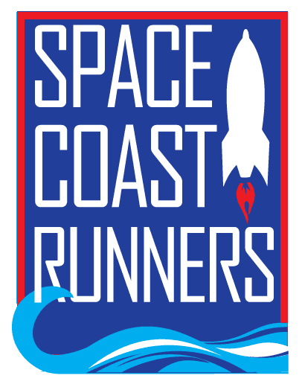
SPACE COAST RUNNERS
MINUTES OF December 2021 BOARD MEETING
Full Board Meeting - 7:00 PM EDT – In Person Meeting
Monday Dec. 13, 2021

Board Members / Officers Present: Debbie Wells (President), Caeley Looney (Vice President), Paul Boucher (Treasurer), Terry Ryan (Secretary), Marisa Flint, Steve Hebert, Kelly Kervin, Brittany Struefort, Donna Arnister, Stephen Bernstein
Absent: Bambi Sweeney, Kim DelTorchio, Rachel Weeks, Kayla Cain.
Meeting called to order at 7:12 pm
- Review of November Meeting Minutes – Terry: Postponed until January meeting due to lack of reviewers

- Marathon Feedback - Debbie –
  - Discussion concerning having a timing mat for ½ distance for the marathoners.
  - Had 7041 registered, 4876 finishers, 3748 completed a challenge. Racers came from 47 states, 13 countries. 79% from FL, 59% were women.
  - The bus service back to hotels was not as good as service to race.
  - Eric Nelson did a great job with the Pizza Tent.

- Scholarship - Donna
    - Letters will go out soon.
    - With the large donations we have had, discussion of whether we should have 4 versus 2 scholarships. We normally receive about 20 applications each year. Paul suggested we grow the pot to invest, not spend it all each year. We may be able to give a larger amount or more scholarships in future, but for now, we all agreed to keep just 2 and grow the base fund.

- Run United - Debbie – Debbie is on the United Way (UW) BOD and they want to bring new organizations into their mix. Program called “Run United” in 26 elementary schools in which UW funds the boom boxes, prizes, software for race results. We could connect this with our Youth Series.
    - Debbie asked if we would allow an email to membership or something in our newsletter telling members about the UW and their run program?
    - Caeley indicated that as long as we give the same opportunity to other groups that might reciprocate.
    - MTA one newsletter Promo – Stephen B. with Caeley second. Approved.

- Space Walk of Fame Race - Brittany
    - Is there any interest in going forward with the club owning 4 races?
    - Discussion about having a 5 mile race
    - Brittany will approach Marty Winkle with options
    - Planning phase for this would be next year

- Budget - Paul
    - November Treasurer’s Report – MTA Stephen B, 2nd Steve H. Approved

    - Budget vs Actual – we are over budget for income, this is good.
- We did not do the $5000.00 track donation this year

    - Budget Overview 2022
- Paul being conservative. He is moving money around based on his experience from the last 2 years.
- Caeley wants to raise product sales from $4000
- Discussion about how we always budget in the red but end up in the black. We have done it this was for years and board has always been happy with this method.
- Kelly pointed out that ROY Races should be $525.00, versus $375.00. Also indicated that we should track how many Corporate 5K runners we have each year.
- Battle of Brevard will need more ribbons for next year.
- 2022-2023 Race Team concept for budgeting purposes is due in February to be presented in March. We currently pay for 40 runners uniforms/clothing.
- Masters Team – Those who Qualified (not just open registration) would have their registrations paid for. Also, the uniforms/clothing
- Agreed to remove the $400 budgeted for board polos
- Agreed to increase brochure budget to $500 from $300
- New budget item is the New Member Packets at $960.00
- RRCA convention reduced from $3000.00 to $2000.00.
- ROY expenses will remain same even though we have about 25% more participants this year.
- MTA budget with corrections Stephen B, 2nd Steve H. Approved

    - Winter Social – Brittany
      - Need help with set up at 6:45 am at Oar’s and Paddles Park on January 16.
      - Early registration for SC Marathon is January 15.
      - Reviewed who was doing what for the social.
      - Will try to have social committee meeting prior to this to finalize.

    - ROY Calculator – Steve
      - The series calculator is working!

Meeting adjourned at 8:44pm

