SPACE COAST RUNNERS

MINUTES OF February 20, 2018 BOARD MEETING

Pro-Health Merritt Island 7:00pm

Board Members / Officers Present: Lisa Hamelin, Bob Rall, Carol Ball, Nancy Foresteire, Bob Alexander, Cyndi Bergs, Keith Dutter, Harry Prosser, Loran Serwin, Howard Kanner

Board Members / Officers Absent: Shelly Williams

- Meeting Call to Order: 7:01 pm
- Review / Modify Agenda: Add new calendar year budget discussion if time allows

Changes to Last Month’s Minutes: Accept Jan. Board Minutes M/S/P Keith/Harry.
- Guests: Brittany Streufert, Linda Schultz, Kelley Lake
- Guest Speaker: Kelley Lake is organizing a 5K, upbeat memorial run in memory of her son Christian Lake. Looking for venue for a mid September Sunday race. Wants proceeds to go to RHS and SCR scholarship fund. Wants to set up foundation to secure sponsorships. If can’t get on ROY series, perhaps SCR could support it as a special event race. She will keep us informed.

Treasurer’s Report 1/31/18 (Carol):

Carol working with accountant on sales tax. Divided out new member packet costs at end of year. Items in new packets under promotional.

M/S/P Harry/Howard to donate 25% of SC Marathon & Half Marathon to Special Olympics. (Bob Rall abstained.) Bob R will be at Eau Gallie HS 2/24 for opening ceremonies and check presentation.

M/S/P Bob R/Keith to accept treasurer’s report:

Savings Account Dec 31 $63,723.55
Interest Jan $1.62
Total $63,725.17
Cash Balance Dec 31 $20,809.27
Total Deposits in Jan $28,317.62
Total Disbursements in Jan ($4,101.72)
Cash Balance Jan 31 $45,025.17
Total All Accounts $108,748.72

Committee Reports

  - Communications Committee (Shelly)
    - Website (Brittany) Small glitch with one member who had different expiration date when she printed her membership card. Brittany worked with her; hasn’t renewed.
    - eBlasts: (Brittany) Howard will put one together for 40th Anniversary Celebration.

Community Committee (Bob A)

Hall of Fame/Golden Shoe Task Force. (Lisa) Lisa, as president, will head up Golden Shoe. Hall of Fame Committee: Carol (past Hall of Fame), Lisa, Bob R. Lisa will email past Hall of Fame members about joining committee.
    - Sunday Runs. M/S/P Harry/Keith, switch RR Sunday Run to go North on 4/29.

Membership December (Brittany) Total membership is 935 members. 95 New members, individual & family combined for January.
    - Coaching (Bob A) 14 people signed up for 5K training program; 2 male, 12 female. Another eBlast will go out this weekend. Registration closes on February 28.
    - Corporate 5K (Carol) Need captain. Info meeting 2/28. Race 4/19. First 20 registrants half price. Lisa will email Shelly & Debbie Wells about captain position.
    - SCR Racing Team (Carol) Did well at EOD, placed 4th. Carol & Debbie Wells manned table at Cape Canaveral Health First Mayor’s Challenge Kick-Off. 2,200 people were involved. We should work closer with them next year. Brittany had no takers on the offered complimentary entry into EOD 10K or Tail of the for the mayors.

Marketing Committee:
    - Swag/Club Branding (Carol) Need to order more items. Send ideas to Carol and then she will place orders.
    - Strategic Planning (Bob R/Harry) (Had Brittany leave room for discussion) Info was put out for DOO. Committee (Bob R, Bob A, Shelly, Harry) pleased with quantity and quality of applications. 12 resumes submitted, top 3 picked, Harry and Bob interviewed them. It was their recommendation Brittany Streufert was best applicant for position. M/S/P Bob R/Harry to offer Brittany DOO position. Bob R will set Strategic Planning Committee meeting to work out independent contractor agreement for one year from date of last signature.
    - RRCA National Convention, Washington DC, April 5-8, Cherry Blossom 10 Miler. Bob R, Carol, Brittany attending. Register by 2/28 to get entry in Cherry Blossom Run.

  - Race Committee (Keith)
    - SCC Course (Brittany) N. Tropical Trail not a good venue. Looking into SE Viera & staging at Church of Viera. Race would have to move to Saturday.
    - EOD Report (Brittany) Attendance down from last year. Slay the Beast sold out at 200 cap. Race went smooth. Looks like $2,000 donation will go to scholarships and $1,000 back to SCR. One timing issue affected 3 people in 40-44 AG. All understanding. Will send recap email and video.
    - ROY Series: (Keith) M/S/P Howard/Bob to keep Island Time in series. Keith abstained. M/S/P Harry/Howard to add Sprint for Sight and increase to 11 race series. Keith abstained. M/S/P Howard/Cyndi to take Reindeer Run out of race and make it a 10 race series. Keith abstained. Lisa will contact Reindeer Run RD. Series: Island Time, Turtle Krawl, Sprint for Sight, SCC, SCM, Tooth Trot, EOD, Downtown Melbourne, Space Walk of Fame, Eat my Crust. 2 drops/6 minimum for points. Lisa will send letters to all RD’s confirming dates and will tighten up getting info for races. Goal to get series info into EMC bags.
    - Race Report: (Keith) Total for Crazy Cupid was 181
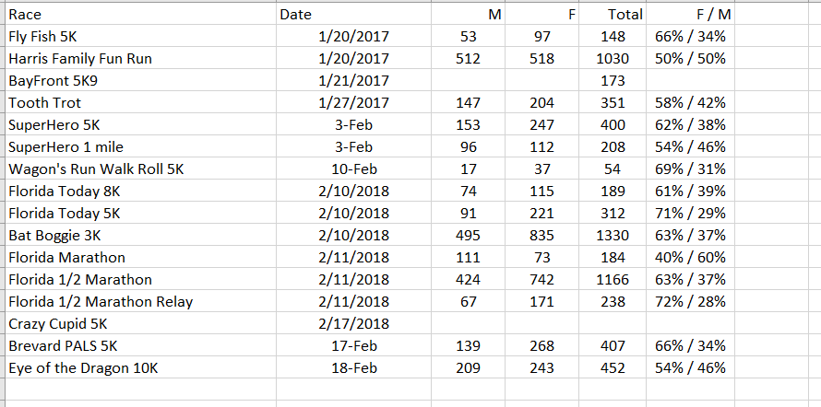
5. SCM Task Force. Will start next month. Mile marker setup removed from SCR responsibilities.
  - SOCIAL COMMITTEE: (Howard)
    - 40th Anniversary Fun Run – Cyndi suggested an historical overlook of SCR with timeline of founding members. Send special invites to original members and hall of famers. Try to get a special guest. Suggest tying it into something special to give back to membership. Possible venue: Florida Beer Company. We can bring food in. Good place to introduce Brittany, then formally introduce her at Celebration Night. Contract Kaitlin Donner to have her talk about her experiences.
    - Awards Banquet – June 3, 2018. Pick name, Carol will get in touch with Pizza Gallery about catering and get pricing for bartender and possible hors devours. Nancy working on silent auction. Asked all board members to get at least one item.
  - BUDGET: (Carol) Redid budget to yearly. Down on marathon budget proceeds, BOD polos, new member packets. Socials we didn’t spend as much so went to 1500. Special Olympics down commensurate with marathon. Bottom line same. Net income $117. Put in expense line for DOO position next month. M/S/P Harry/Keith to approve revised budget.
- Next Meeting – Monday, March 19, 2018, 7pm at Merritt island ProHealth
- Adjournment – M/S/P Bob R/Harry adjourn 9:04 pm.

Minutes prepared by Nancy Foresteire

