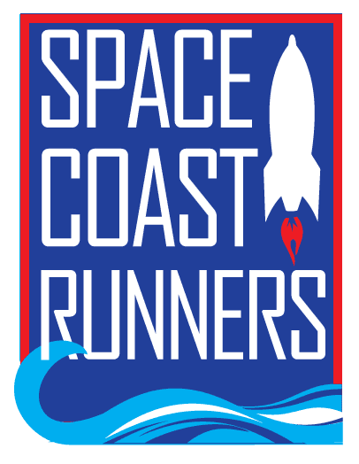
SPACE COAST RUNNERS
MINUTES OF April 20, 2020 BOARD MEETING
Virtual, 7:00P

Board Members / Officers Present: Debbie Wells (President), Caeley Looney (Vice President), Bob Rall (Treasurer), Elisha Gould (Secretary), Jessica Frank, Stephen Bernstein, Lindsey Sodemann
Director of Operations: Brittany Streufert
Board Members / Officers Absent: N/A
Guests: Paul Boucher

- Meeting Called to Order: 7:06pm
- Review and Approval of March 2020 Minutes: MSP Stephen/Lindsey
- Review and Approval of Treasury Report
  - Review Treasury Report - MSP Stephen/Jessica
- Critical Topics
  - Racing Team Proposal
    - Traditional SCR Racing Team
Will have the award for meeting team obligations be the following year's membership paid. MSP Bob/Stephen
***Team Expectations are as listed on the application:
(1) Represent SCR as a Club/Team ambassador. Wear your current SCR singlet at all Brevard races. (2) Pre-register and run/compete in at least 6 SCR 2020-2021 ROY races. If race includes a team category, members will register as “SCR Racing Team”. (3) Volunteer at 4 or more SCR ROY events throughout the season. (examples: packet pickup, water stations, trash cleanups, etc.) (4) We encourage you to volunteer at 3 non-ROY SCR activities. (examples: fun run support, socials, Celebration Night, At-large Board member, sponsor development, etc.) While not required, as ambassadors your help is key to successful events. (5) Consent to use of image for marketing purposes. (6) Sign a Code of Conduct agreement.
    - SCR Masters Team
People can be on both teams, no conflict - can also be on the Master's team if they are on other racing teams, ie Viera Pizza, East Coast Runners, etc. The Master's team is to be constructed as a competitive team. Board thinks we should add timing questions to application if we are picking the team for speed/competition. Thinking about sending out invites to participants but will also open to applications. Debbie will lead the direction of the team, but we will also look for an "elite" team captain. Will have a FB Live information session/meeting to give interested members additional details, by end of this week. Debbie/Brittany will set up and facilitate.
    - Deadline to submit is 5/15
  - Eat My Crust Update
Running Zone thinks June races will run, Brittany isn't sure - decided to wait until next meeting to decided on EMC. Update via Social Media 5/6 to turn into a virtual.
- Unfinished Business
  - Current ROY Series
Deciding to wait until 5/18 meeting. Due to EMC virtual announcement on 5/6 - the current ROY Series has ended and the ROY Series results have been announced and awards email sent.
  - Run Social
Brittany has not ordered the materials yet, but will this month because we can use the beach run type charm even if the Run the Tide doesn't run.
- Reporting
  - Space Coast Classic 15K & 2 Miler
Brittany (Race Director) presented Race Report - race turned into virtual, good results - including new sign ups since it was turned virtual. Board had no questions.
- New Business
  - Marketing & Communications Committee - Lindsey Sodemann
    - Socials - Social committee met last week & they're just in a holding pattern until we know more.
      - Celebration Night
Celebration Night maybe in August - not really wanting to do a virtual.
      - Summer Social - Debbie Wells, Chair
Possibly combine with Battle of Brevard. Make it kind of like winter social instead of a bigger event like we usually do.
      - Battle of Brevard
Tentatively 7/29, a Wednesday
    - Next Meeting - 5/18 6pm Virtual
  - Community Engagement Committee - Elisha Gould, Chair
    - High School Scholarship - notifications sent, will post in newsletter and social. Debbie suggested we send a "with regrets" email to the applicants that were not awarded the scholarship.
    - Social Competitions - Let Brittany know if you think of anything for the weekly social media contests.
    - Coaching/Training Camps
Only 6 people from current camp have deferred when offered. Kaitlin is considering a summer and fall camp with Board approval. The Board said it's ok to proceed.
    - Hall of Fame/Golden Shoe Task Force - Taking nominations now - Brittany put into last newsletter & is making social posts.
    - Upcoming Board Elections
We need get the new board elections started - due to be voted on in May and inducted at June meeting. Current Board Members need to let Debbie/Brittany know if they want to resubmit and what positions. Debbie will contact new members and put out invites to the Board to bring in new insights.
- Next Meeting - Monday, May 18, 7pm Virtual
- Adjourn - 8:15p
Minutes Prepared by Elisha Gould, SCR Secretary

