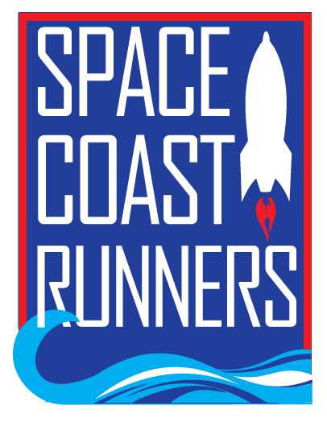

SPACE COAST RUNNERS
MINUTES OF March 2024 MEETING
6:30 PM EST – In Person Meeting
St Francis Reflections Board Room: 6905 N. Wickham Rd., 3rd Floor.
Monday, March 18th, 2024

Board Members / Officers Present: Terry Ryan (President), Brittany Streufert (Director of Operations), Galyn Sehnk (Vice President), Chris Kelly, Kelly Kervin (Secretary), Nicole Cash-Ianello, Steve Hebert, Vish Ramachandran, Donna Arnister and Alex Lipford
Board Members Virtual: Stephen Bernstein
Board Members Absent: Paul Boucher (Treasurer) and Johanna Ramirez
Guest: Michelle Maricic
Meeting called to order at 6:31 PM
- Special Guest Presentation: One Medal – Michelle Maricic
  - Michelle presented the One Medal program to the board. It was established about 10 months ago and has applied for a 501©3 status but is currently not profitable enough to donate money to charity yet. The goal is to do that moving forward. Michelle is requesting to partner with Space Coast Runners and the Runner of the Year Series.
  - The board members had a brief discussion about the program. No motion or vote taken, pushed to the April meeting.
- Review of January Meeting Minutes – MTA from Terry, 2nd by Nicole. Passed.
- Treasurer’s Report – Terry
  - The board agreed to defer the December, January, and February Treasurer’s reports to an online vote. They were uploaded late, and the board was not able to view them before the meeting. The votes will take place individually and reported on at the April meeting.
- Direction of Operations Report – Brittany
  - Membership is 1,035
  - Training Camps
      - The 16-week Training Camp is going well.
  - Retail
    - Sold $956 in February.
  - The next random runner will be selected from the Downtown Melbourn 5K. Keith is the photographer.
  - Celebration Night
    - Pavilion is confirmed for Wickham Park
  - Board Elections
    - An email will be sent out for nominations.
    - Kelly Kervin, Nicole Cash-Ianello, and Donna Arnister said they would not be returning to the board next season.
  - Space Coast Marathon registration is stronger this year than it was at the same time in 2023.
  - Sponsorships
    - Kelly made a motion to accept $1,500 in gift cards from Running Zone as a sponsorship, Alex 2nd. Passed.
    - Ed Donner Wealth Management confirmed their sponsorship for 24-25.
  - Master’s Team
    - Approval is not needed to be added to the team.
  - Corporate 5K
    - 9 of the 20 discounted spots have been registered for.
  - Christian Lake Memorial Scholarship Fund
    - Winners have been selected and notified. They will be invited to read their speeches at Celebration Night.
- Committee Reports
  - Social – Johanna
    - Celebration Night hours are 4 PM-7 PM
    - Blue Jean Mile is TBD
    - April 27th is the tentative date for a 520 Road Clean-Up
    - Fight Child Hunger is scheduled for October 24th from 5:30 PM-8:30 PM
    - Individual goldfish packages will be collected through Eat My Crust 5K for the AKA Sorority
      - These are donated to students suffering from food insecurity.
  - Race Committee – Kelly
    - The race committee discussed the One Medal Program and unanimously voted not to support it being added to the Runner of the Year Series.
    - The Ran All Races Award for the 24-25 season will be a blanket.
  - Youth Series – Donna
    - Calendar is set for the 2024-2025 season.
  - Race Results – Steve
    - Results were placed in the drive.
    - Race numbers are stronger than last year.
  - Master’s Team – Stephen
    - Stephen will email Brittany updates.
- President’s Report – Terry
  - Space Coast Classic 15K & 2 Mile
    - Registration looks stronger than prior year.
    - There needs to be a push for the 2 Mile distance.
  - Annual Membership Meeting
    - Set for June 10th at St. Francis Reflection Board Room
Motion to Adjourn by Kelly 2nd by Alex by Meeting adjourned at 7:51 PM

