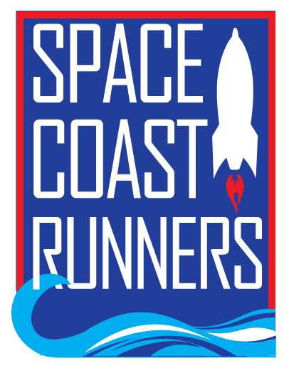

SPACE COAST RUNNERS
MINUTES OF SEPTEMBER 2023 MEETING
6:30 PM EST – In Person Meeting
St Francis Reflections Board Room: 6905 N. Wickham Rd., 3rd Floor.
Monday, September 25, 2023

Board Members / Officers Present: Terry Ryan (President), Paul Boucher (Treasurer), Brittany Streufert (Director of Operations), Galyn Sehnk (Vice President), Donna Arnister, Chris Kelly, Kelly Kervin (Secretary), Nicole Cash-Ianello, Stephen Bernstein, Steve Hebert and Vish Ramachandran
Board Members via Google Meet: Johanna Ramirez and Bambi Sweeney
Board Members Absent: Alex Lipford
Guest: Nancy Foresteire
Meeting called to order at 6:32 PM
- Review of August Meeting Minutes – MTA from Steve, 2nd by Nicole. Passed.
- Treasurer’s Report – Paul
  - Paul is seeking permission to explore alternative bank options. One of the biggest complaints is our current bank only has one physical location.
  - Motion to Approve a Resolution for Paul to close the account at Sunrise Bank by Terry, 2nd by Stephen. Passed.
  - Motion to Approve Paul opening a bank account at a new bank (TBD) by Kelly Kervin, 2nd by Stephen. Passed.
- Save Our Trees Update – Guest Speaker
  - Space Coast Runners Newsletter included a Call to Action to save the trees along Rockledge Drive.
  - The newsletter placement was approved by Brittany after SCR supported the initiative three years ago under former President Debbie Wells.
  - The guest was concerned with the way it looked and would open SCR up to include any Call to Action that members submit.
  - Discussion ensued and Brittany will seek permission before including similar ads again.
- Direction of Operations Report – Brittany
  - Membership is 1,010
  - Training Camps
    - Let’s Go! 12 Week finished at Turtle Krawl 5K.
    - 16 Week Fall Camp has 96 participants and 8 pacers.
    - Let’s Go! Holiday Camp starts November 1st, aimed at beginning runners.
  - Retail
    - Sold $479 in August which is higher than the previous year.
  - Random Runners was selected for Turtle Krawl 5K.
  - MTA Bereavement money added to member collected donations for the Shenbaum family by Kelly, 2nd by Stephen. Passed.
  - Monthly Meet Ups are moving to Social Committee
- Committee Reports
  - Race Results - Steve
    - Virtual races are not included in the race statistics.
  - Race Committee – Kelly
    - The race committee discussed the short course for Turtle Krawl 5K. Runners turned down Tampa, not Deland which made a 3-mile course. This was a RZ sign error.
    - Sprint for Sight 5K does not have a virtual option. The race committee was asked to consider allowing members to submit their results to us for Ran All Races Credit, this motion did not pass.
      - Members asked during the All in One Special about this and were told a virtual option was not an option. To make an exception now would be unfair.
      - Virtual races are not required by SCR to be in the series.
  - Social - Johanna
    - Carol Ball would like to do another beach cleanup. The clean up in September was a success.
    - Marathon Clean Up
      - West Shore Jr/Sr HS Cross Country has the north course.
      - Viera High School Cross Country has the south course.
    - Next social committee meeting is October 2nd on Zoom.
  - Youth Series - Donna
    - 116 children participated at Cocoa High School.
      - 84 of these children were also at Viera High School.
    - Ran smoother than the first race because expectations were adjusted for a bigger crowd.
    - Donna requested Brittany order 100 more yellow shoe charms. Brittany said yes and all other items asked to be reordered have been.
  - Newsletter - Chris
    - Next newsletter is coming out October 5th.
  - Master’s Team – Stephen
    - 10/22 Martin County
    - 10/28 Ormond Beach
    - 11/5 Golden Age in Sanford
    - 2 new members have joined the Master’s Team
- President’s Report – Terry
  - MAM to update the Hall of Fame and Golden Shoe criteria by Kelly, 2nd Gayln. Passed.
Motion to Adjourn by Kelly 2nd by Stephen by Meeting adjourned at 8:14 PM

