Broadside Harbor Open Water Swims
Non USMS Sanctioned Event
“1 mile” and “2 mile”
June 12, 2021

Meet Registration Form

Location: Broadside Harbor Ski Lakes, 21600 Look Ln, Caldwell ID 83607

Races: Entry Fees (includes all races) and Deadlines:
•One-mile swim Entries received on or before June 10, 2021: $15
•Two-mile swim Entries received on or after June 11, 2021: $20

Schedule: 10:30 a.m. Prerace check-in and safety meeting
11:00 a.m. Start of 1-mile swim
12:15 p.m. Start of 2-mile swim

Start/finish: Swimmers will start in the water and will finish by going through a chute.

Course: The 1-mile race will be an out and back of one lake. The 2-mile swim will be two circuits out and back of the same lake.

Age Groups: 18-24, 25-29, 30-34, and so on in 5-year increments

Results: Will be posted online at www.Sawtoothmasters.org
Post-Race Paper ware and non-alcoholic beverages will be provided.
Potluck Picnic: Please bring a dish to share.

Questions: Event Director Jill Wright: 208-571-4254 swimjmw@msn.com

Mail Entries to: Jill Wright
Sawtooth Masters
1626 Williams St.
Boise, ID 83706

All swimmers must sign liability form attached – no exceptions.

FACILITY DETAILS:

Location: Broadside Harbor Ski Lakes, 21600 Look Ln, Caldwell ID 83607

Directions: From Boise, travel west on l-84. Take exit 26. Turn left (towards Notus/Parma) on Hwy 20/26 and follow for approximately 0.5 mile. Turn left on Look Lane. Follow Look Lane over the railroad tracks and turn left on Broadside Harbor Lane (dirt road). Follow to the lakes. Please park in the dirt lot to the west of the house.

Water Temperature: Approximately 70⁰F.
Parking: Handicap parking available nearest the house.
Dogs: No dogs are allowed on the dock. Dogs must be leashed and owners must clean up after their animals.

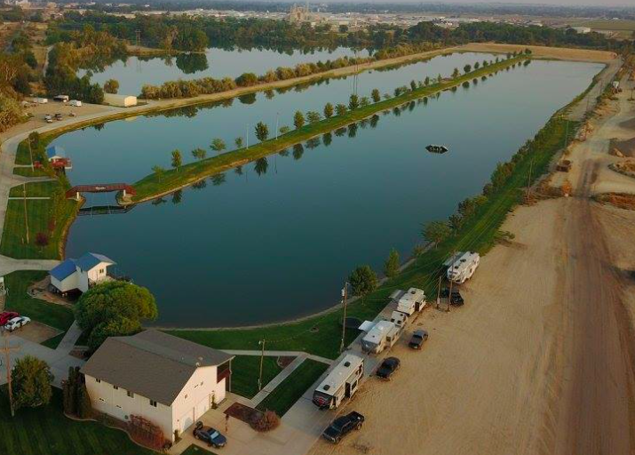
Broadside Harbor Open Water Swims
1 mile and 2 mile OW Swim

OFFICIAL ENTRY FORM
June 12, 2021

Last Name:*_______________________________ First: _______________________________ MI: ___
Street Address: ___________________________ City:____________________ State:____ ZIP:_______
E-Mail: _______________________________ Day Phone: ______________ Eve. Phone: ___________
Emergency Contact: __________________________ Phone: ______________ Age: ____ (on 6/12/2021) **
D.O.B: ____________ Sex: ____

Entry Fees and Deadlines
Circle all events you wish to swim:
One-Mile Swim Two-Mile Swim
 | FEE |  | TOTAL
1st Registration Period Opens April 18, 2021  1st Registration Period Closes June 10, 2021 | $15 |  | $
2nd Registration Period Opens June 11, 2021  2nd Registration Period Closes June 12, 2021 | $20 |  | $
TOTAL AMOUNT DUE
Donation to Sawtooth Masters |  |  | $

Make Check or money order payable to: Sawtooth Masters

MAIL ENTRIES TO: Jill Wright, Sawtooth Masters, 1626 Williams St., Boise, ID 83706

Be sure to sign and include the liability waiver below:

