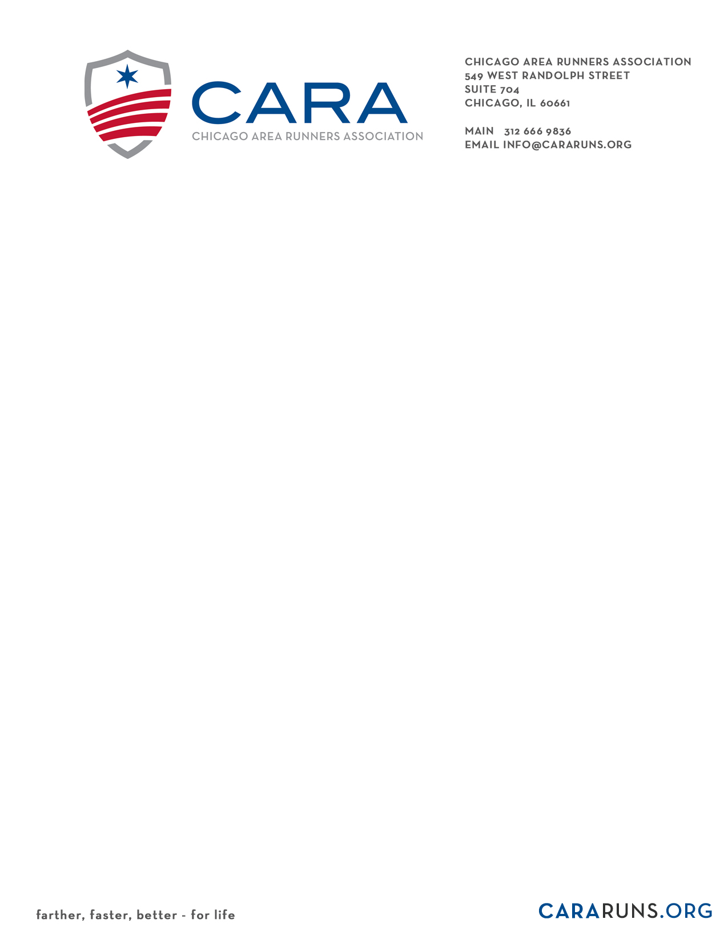

BOARD OF DIRECTORS APPLICATION

Fact Sheet and Conflict of Interest Declaration Form

The following criteria are expected of all CARA Board members:

- Upon acceptance to the board, and prior to the first board meeting, must be a CARA member in good standing.
- Active participant in the Chicago area running community.
- Will attend at least 75% of board meetings, typically held on the second Thursday of each month (8-10 meetings a year).
- Able to attend additional special meetings as needed.
- Will lead or serve on a minimum of one committee of the board during tenure as a board member.
  - Program
  - Medical
  - Development
  - Governance & Bylaws
  - Membership
  - Nominating
  - Racing
- Will contribute at least $500.00 annually as a financial commitment to CARA OR run for Team CARA as a charity fundraiser and meet all minimum fundraising requirements of such, but no less than $1,000. This is a donation above the membership dues.
- Volunteer for CARA programs, events and/or support roles a minimum of 12 (twelve) hours per year, in addition to board of directors and committee meetings. Volunteer hours should include at least any two (2) of the following:
  - Awards Luncheon in January/February
  - Lakefront 10 Miler and 5k in March/April
  - Super Clinic in May/June
  - ‘Go Runs
  - Group Leader in one of the CARA training programs
  - Ready to Run 20-miler in September
  - Chicago Marathon VIP experience
  - Volunteer Appreciation Reception in October/November

If you meet the above criteria please complete the questions below and follow the submission instructions at the end. Your application will be considered by the nominating committee and selections are made based on applicants who best fit the current needs of the organization at the time an opening is available. Please provide as much detail as possible to help the nominating committee learn about you and your potential contributions as a CARA board member.

Name:

Address:

City/State/Zip:

E-mail:

Telephone (home):
(work)
Education (include degrees/certifications):

Employer:

Occupation/title:

Number of years you have been running:

Special interests (include interests in other sports):

What other Boards have you or do you serve on (include dates)?

How long have you been a CARA member (if applicable)?

Describe any previous involvement with CARA (i.e. board committees, race participation, training programs, volunteering at events, etc.).

Why do you want to be a CARA Board member?

What do you consider to be your qualifications to serve on the Board?

What do you view as the significant issues facing the sport of running?

Explain briefly what you see as the significant issues facing CARA and how CARA might address the issue(s)?

Have you, or do you expect to, receive payment for services from any of the following organizations or individuals: vendors, consultants, contractors, race organizations or managers, who have existing contracts, or contract proposals pending, with CARA? If yes, please identify them.

Do you have any official connection or relationship (as a board member, employee, consultant, volunteer leader, paid or unpaid advisor, or other official representative) with any of the following organizations or individuals: vendors, consultants, contractors, race organizations or managers, who have existing contracts, or contract proposals pending, with CARA? If yes, please identify them.

Do you have any official connection or relationship (as a board member, employee, consultant, volunteer leader, paid or unpaid advisor, or other official representative) with any of CARA’s competitors? If yes, please identify them. (Competitors are defined as other organizations which offer programs similar to CARA’s. Please disclose all relationships. Involvement in these organizations won’t necessarily exclude you from consideration for CARA’s board.)

Signature of Applicant ___ _____________________ Date_______
Note: Electronic signatures are okay if submitting by e-mail.

Please submit this form to Betsey Madden, Chair of the Nominating Committee, at betsey.madden@sbcglobal.net

11/2017

